|  |  |
| --- | --- |
| Team ID | PNT2022TMID26125 |
| Project Name | Inventory Management System for Retailers |

Steps:

Create a Kubernetes cluster

* Sign in to your [IBM Cloud Dashboard.](https://cloud.ibm.com/dashboard/apps/?cm_sp=ibmdev-_-developer-tutorials-_-cloudreg)

* Open **IBM Kubernetes Service**.

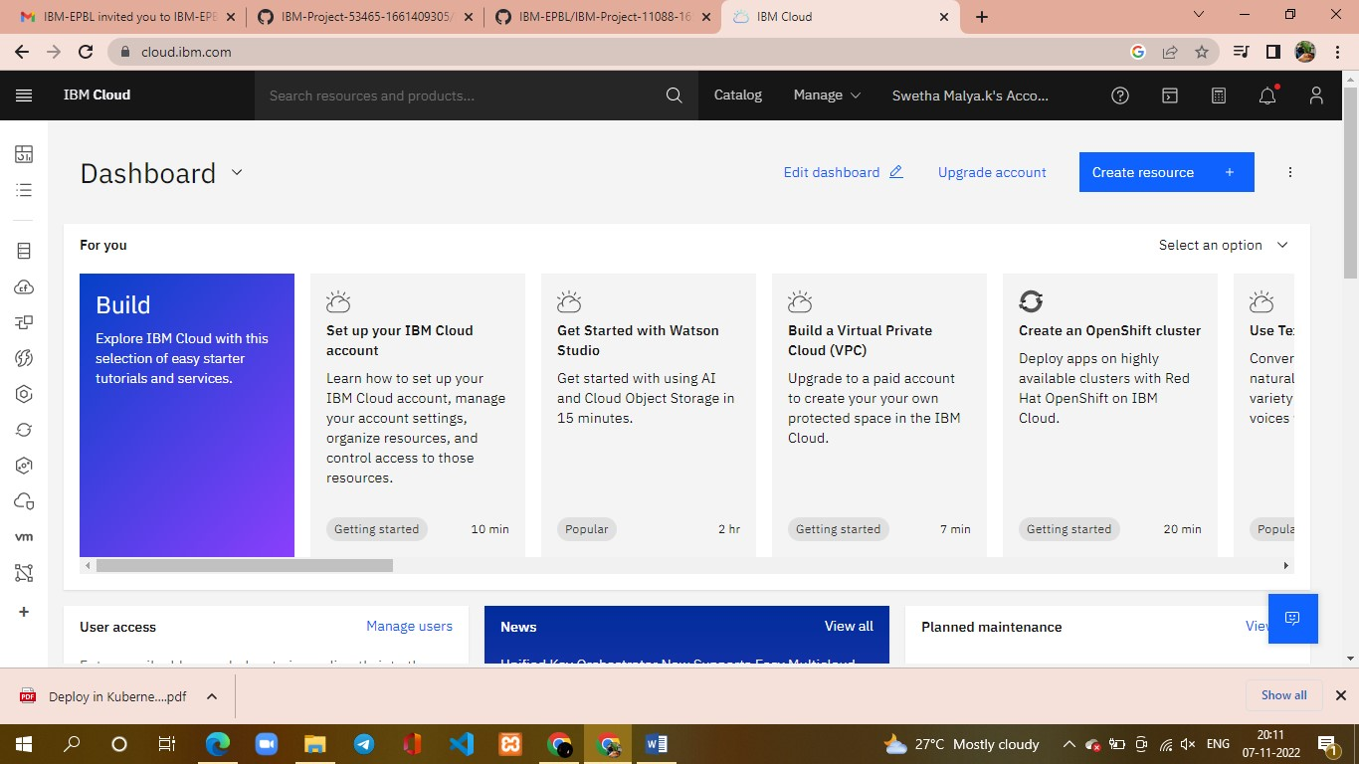

* Click **Create Cluster**.

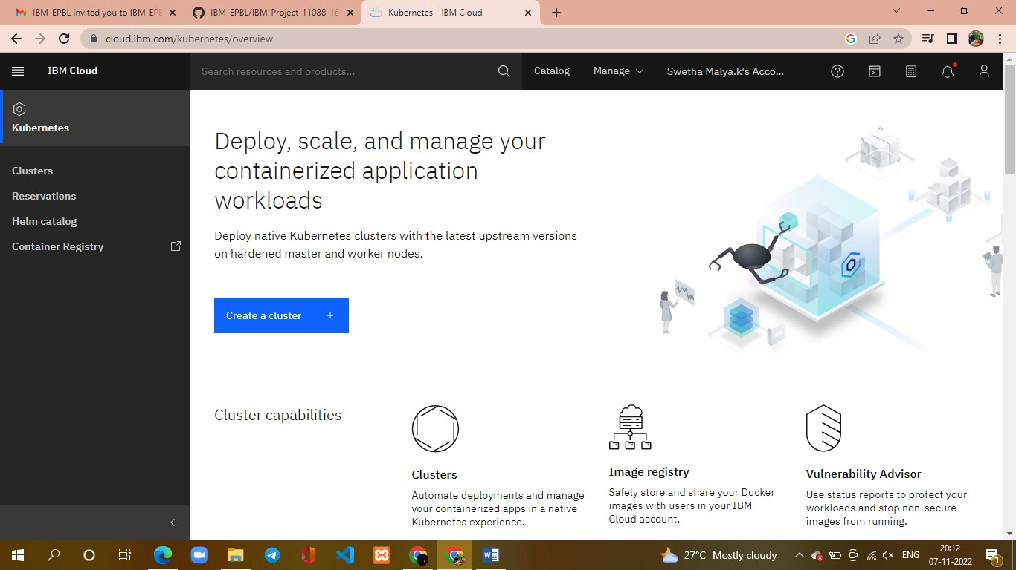

* Select the **Region** where you want to deploy the cluster, type in a **name** for your cluster, then click **Create Cluster**.
* Select the appropriate cluster type depending on your account.
* It takes some time for the cluster to get ready (around 30 minutes).

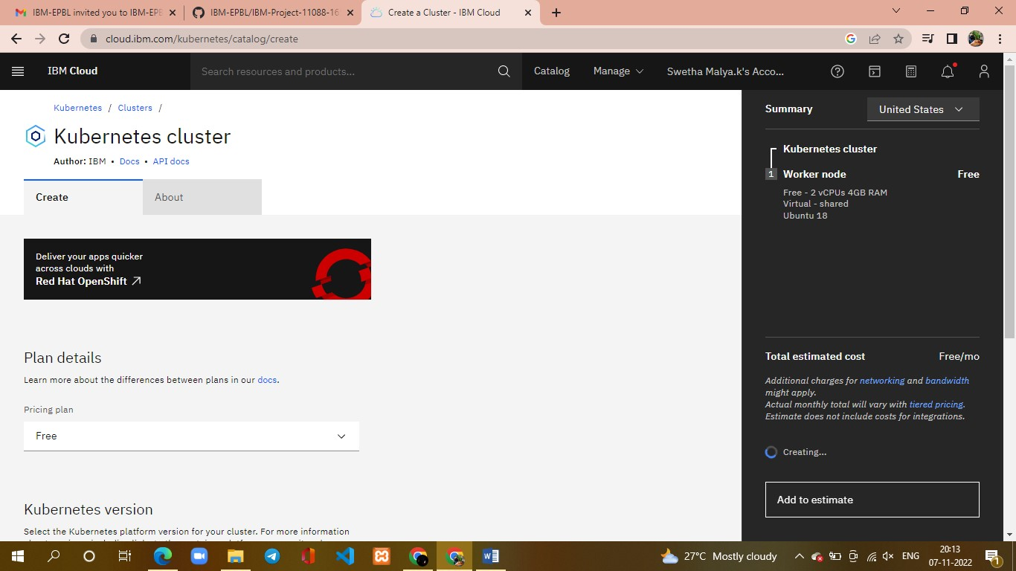

* Once the cluster is ready, click on your cluster's name and you will be redirected to a new page with information about your cluster and worker node.

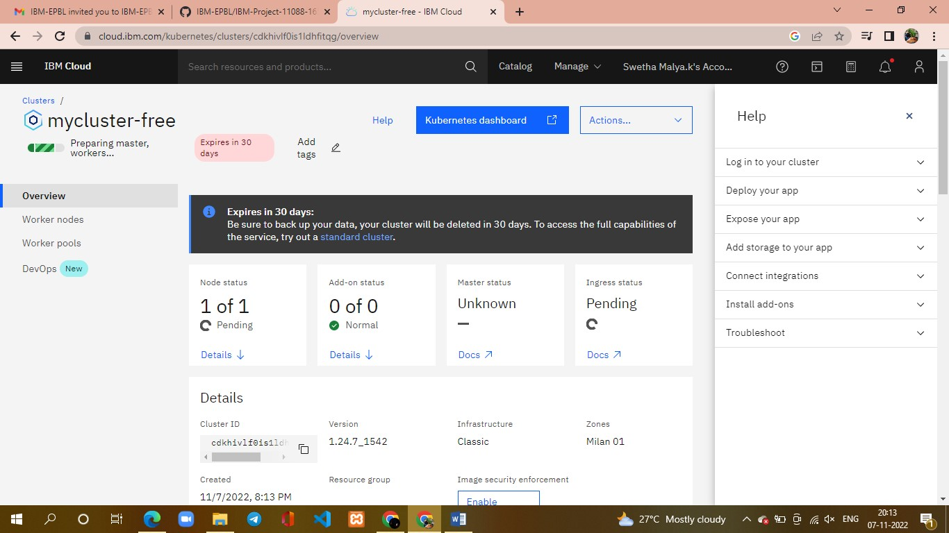

* Click on the **Worker Nodes** tab to note the cluster's Public IP.

